

11\A – 37

Muhammed ERKAM SAY

Nuvoton M031FB0AE kartı tanıtım dökümanıdır.

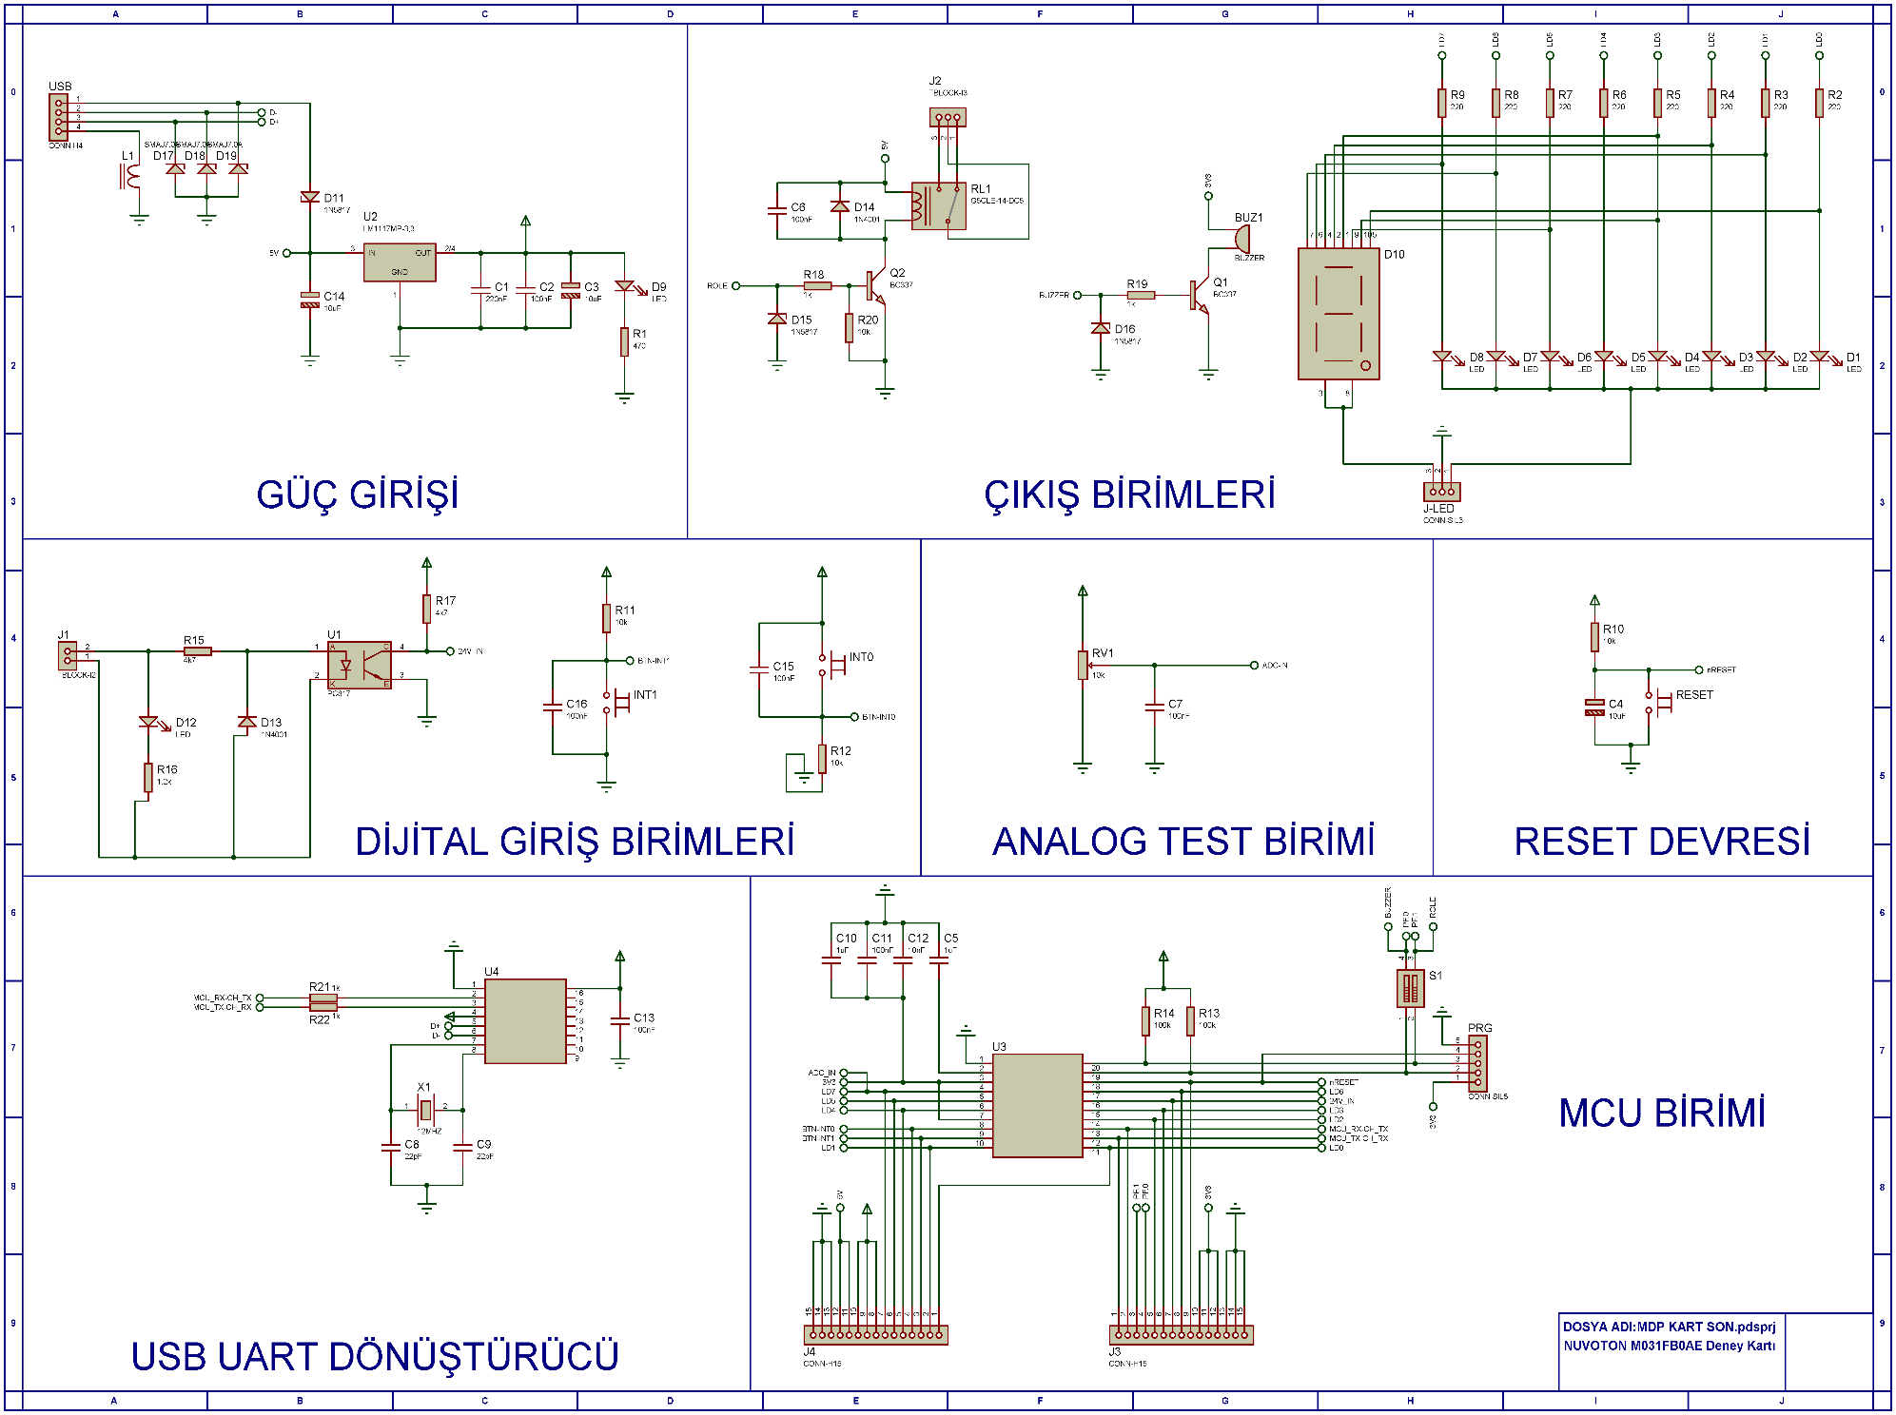

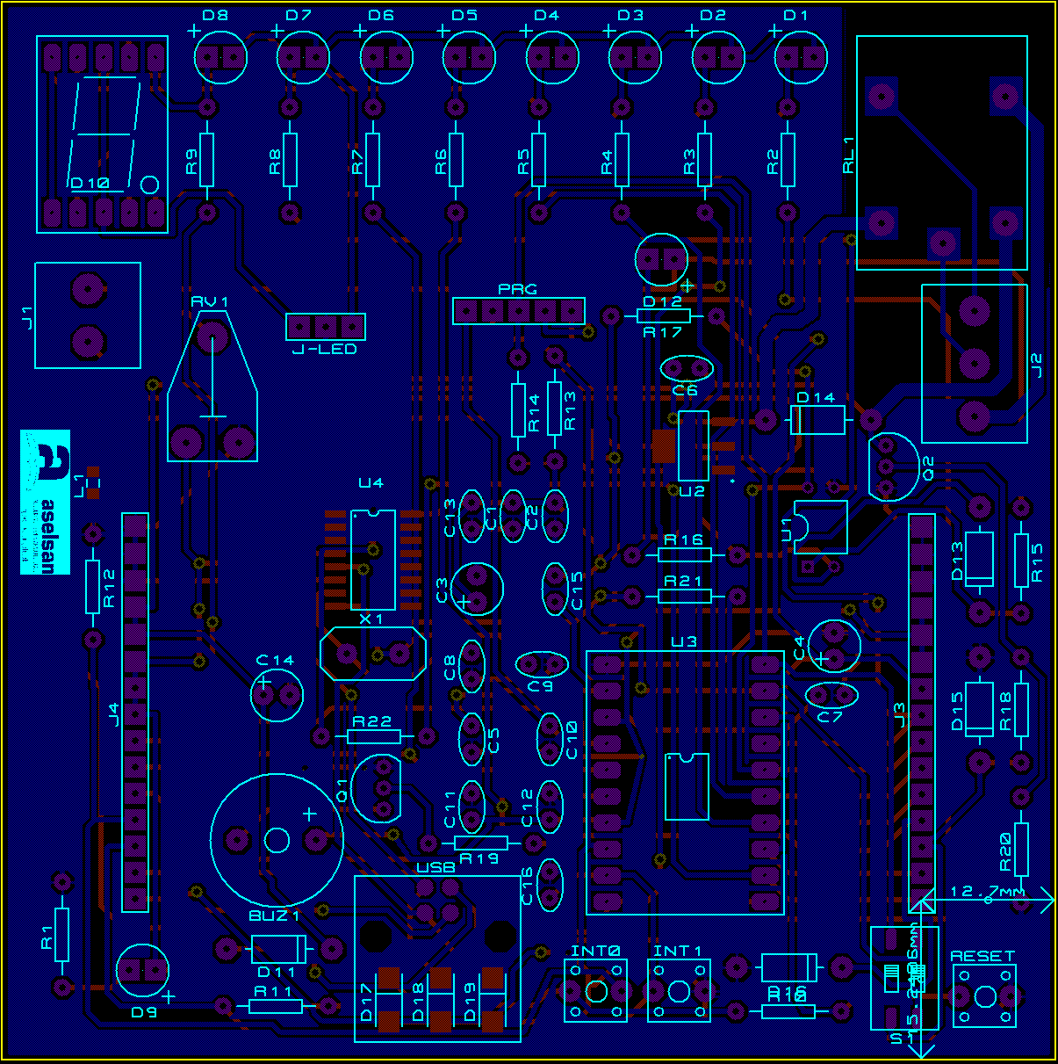

**GENEL BASKI DEVRE GÖRÜNÜŞÜ**

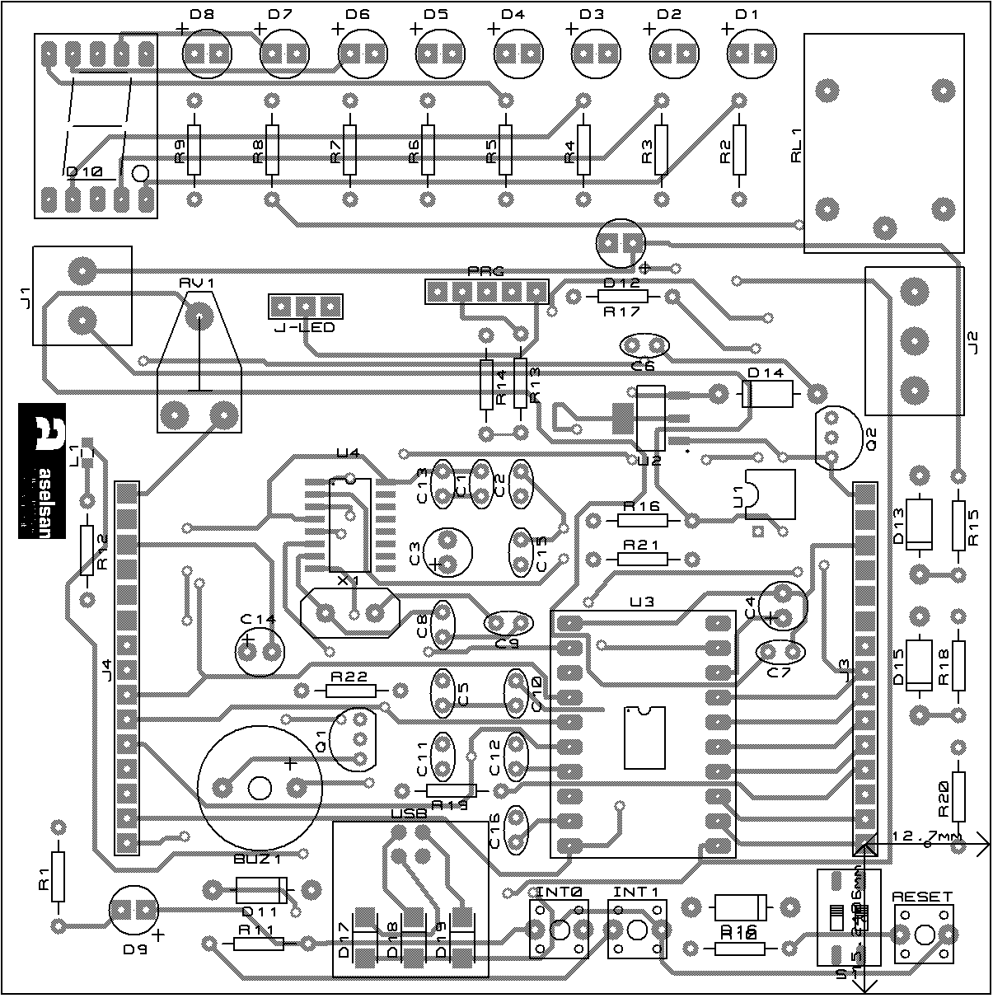

**ÜST KATMAN YERLEŞİM PLANI**

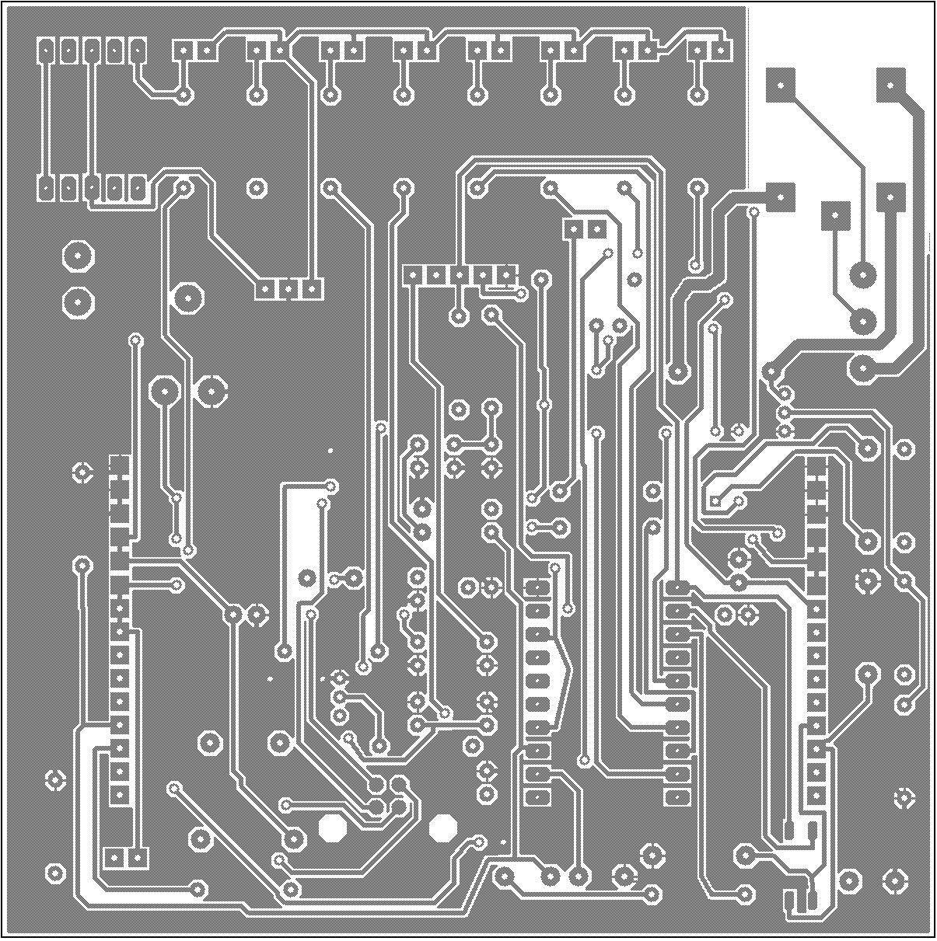

**ALT KATMAN YERLEŞİM PLANI**

Bill Of Materials for MDP KART SON

Design Title MDP KART SON

Author

Document Number

Revision

Design Created 25 Nisan 2023 Salı

Design Last Modified 25 Nisan 2023 Salı

Total Parts In Design 79

|  |  |  |  |  |
| --- | --- | --- | --- | --- |
| 0 Modules | |  |  |  |
| Quantity References | | Value | Stock Code | Unit Cost |
| Sub-totals: | |  |  | ₺0,00 |
| 16 Capacitors | |  |  |  |
| Quantity | References | Value | Stock Code | Unit Cost |
| 1 | C1 | 220nF |  |  |
| 7 | C2,C6-C7,C11,C13,C15-C16 | 100nF |  |  |
| 3 | C3-C4,C14 | 10uF |  |  |
| 2 | C5,C10 | 1uF |  |  |
| 2 | C8-C9 | 22pF |  |  |
| 1 | C12 | 10nF |  |  |
| Sub-totals: |  |  |  | ₺0,00 |
| 22 Resistors |  |  |  |  |
| Quantity | References | Value | Stock Code | Unit Cost |
| 1 | R1 | 470 |  |  |
| 8 | R2-R9 | 220 |  |  |
| 4 | R10-R12,R20 | 10k |  |  |
| 2 | R13-R14 | 100k |  |  |
| 2 | R15,R17 | 4k7 |  |  |
| 1 | R16 | 1.2k |  |  |
| 4 | R18-R19,R21-R22 | 1k |  |  |
| Sub-totals: |  |  |  | ₺0,00 |
| 4 Integrated Circuits | |  |  |  |
| Quantity | References | Value | Stock Code | Unit Cost |
| 1 | U1 | PC817 |  |  |
| 1 | U2 | LM1117MP-3,3 |  |  |
| 2 | U3-U4 |  |  |  |
| Sub-totals: |  |  |  | ₺0,00 |
| 2 Transistors |  |  |  |  |
| Quantity | References | Value | Stock Code | Unit Cost |
| 2 | Q1-Q2 | BC337 |  |  |
| Sub-totals: |  |  |  | ₺0,00 |
| 19 Diodes |  |  |  |  |
| Quantity | References | Value | Stock Code | Unit Cost |
| 10 | D1-D9,D12 | LED |  |  |
| 1 | D10 |  |  |  |
| 3 | D11,D15-D16 | 1N5817 |  |  |
| 2 | D13-D14 | 1N4001 |  |  |
| 3 | D17-D19 | SMAJ7.0A |  |  |
| Sub-totals: |  |  |  | ₺0,00 |
| 16 Miscellaneous | |  |  |  |
| Quantity | References | Value | Stock Code | Unit Cost |
| 1 | BUZ1 | BUZZER |  |  |
| 5 | INT0-INT1,L1,RESET,S1 |  |  |  |

# J1 TBLOCK-I2

|  |  |  |
| --- | --- | --- |
| 1 | J2 | TBLOCK-I3 |
| 2 | J3-J4 | CONN-H15 |
| 1 | J-LED | CONN-SIL3 |
| 1 | PRG | CONN-SIL5 |
| 1 | RL1 | G5CLE-14-DC5 |
| 1 | RV1 | 10k |
| 1 | USB | CONN-H4 |
| 1 | X1 | 12MHZ |
| Sub-totals: ₺0,00 | | |

Totals: ₺0,00

25 Nisan 2023 Salı 21:34:26

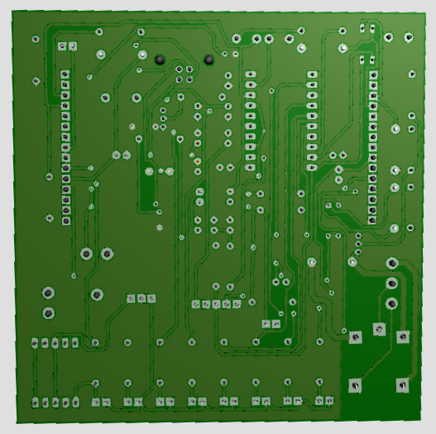

**ALT KATMAN 3D GÖRÜNTÜ**

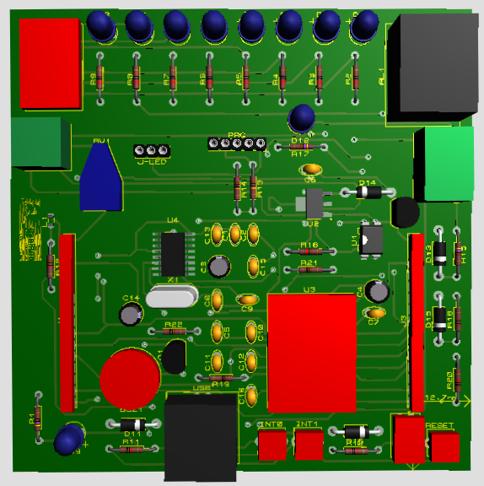

**ÜST KATMAN 3D GÖRÜNTÜ**